**FIRE SAFETY PLAN**

**Business name**

**Address**

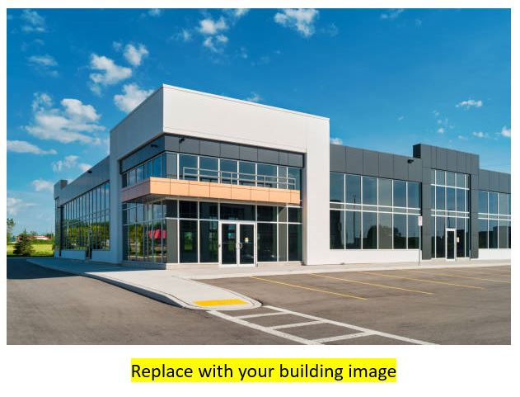

Created April 2024

**GUIDELINES FOR USING THIS TEMPLATE**

This template is provided as a resource to help business owners develop a fire safety plan that adheres to the National Fire Code Alberta Edition. If there is any inconsistency between the information in this template and the Safety Codes Act, National Fire Code Alberta Edition, or other applicable code or referenced standard, the legislation is considered correct.

This template is meant to be modified to reflect your building or business’s operation. Areas highlighted in yellow should be updated to your specific needs. Other areas may also be modified as necessary. Ie. references to a fire alarm system or kitchen suppression operating instructions should be modified or removed if your building does not have them installed.

If you have any questions regarding the use of this template, please contact [fireprevention@medicinehat.ca](mailto:fireprevention@medicinehat.ca).

This page can be removed.

**Table of Contents**

Part 1 Introduction

Part 2 Emergency contact information

Part 3 Building fire and life safety features

Part 4 Emergency procedures

If you discover a fire

Fire extinguishment

Responding to a fire alarm

Silencing a fire alarm

Part 5 Fire hazards

Part 6 Staff training

Part 7 Fire protection maintenance requirements

Part 8 Building diagrams

**Part 1 - Introduction**

The National Fire Code – 2023 Alberta Edition requires the implementation of a Fire Safety Plan for this building. The National Fire Code Alberta Edition can be purchased or viewed on the National Research Council website.

This Fire Safety Plan is intended to ensure the safety of building occupants by providing building owners and staff with the necessary knowledge to prevent fires from happening, maintain fire protections systems in a ready state, and respond appropriately in the event of a fire emergency.

This Fire Safety Plan shall be kept in the building for reference by the fire department, supervisory staff, and other personnel.

The Fire Safety Plan can be found location

**Posting of Emergency Procedures**

Fire Emergency Procedures are required to be posted in floor areas throughout the building. Fire safety rules for occupants must be posted in every hotel room, showing the location and path of travel to exits.

**Annual Review**

This Fire Safety Plan must be reviewed at intervals not greater than 12 months to ensure it takes account of changes in the use and other characteristics of the building.

**Building owner responsibilities**

The owner or the owners authorized agent shall be responsible for carrying out the provisions of the National Fire Code Alberta Edition.

This includes designating supervisory staff, ensuring staff are trained on the fire safety plan, and ensuring necessary tests, checks and repairs, are being performed on fire protection equipment in accordance with the National Fire Code Alberta Edition.

**Part 2 - Emergency Contact Information**

**Emergency Services**

|  |  |
| --- | --- |
| In case of emergency | 9-1-1 |
| Medicine Hat Fire non-emergency | 403-529-8282 |
| Medicine Hat Police non-emergency | 403-529-8481 |
| Medicine Hat Hospital | 403-529-8000 |
| Gas utility | 403-529-8191 |
| Power utility | 403-529-8260 |
|  |  |
|  |  |

**Designated Supervisory Staff**

|  |  |  |
| --- | --- | --- |
| Name | Position | Phone |
|  |  |  |
|  |  |  |
|  |  |  |
|  |  |  |
|  |  |  |
|  |  |  |
|  |  |  |

**Fire Protection System Servicing Contacts**

|  |  |  |
| --- | --- | --- |
| Fire alarm system |  |  |
| Fire sprinkler system |  |  |
| Fire alarm monitoring |  |  |
|  |  |  |
|  |  |  |
|  |  |  |
|  |  |  |

**Part 3 - Building Fire and Life Safety Features**

|  |  |
| --- | --- |
| Building name |  |
| Building description |  |
| Muster point |  |

**Fire Alarm System**  Yes No

The fire alarm system is a combination of devices including heat and/or smoke detectors, manual pull stations and audible signal devices that are intended to warn building occupants of an emergency fire condition. When activated, the fire alarm system may be programmed to control certain building systems such as air handling systems or fire doors to prevent the spread of fire or smoke. The fire alarm system can be activated automatically by detection devices or manually by pulling a manual pull station. Manual pull stations are typically located adjacent to exit doors.

False alarms occasionally occur when the fire alarm system activates for reasons other than a fire. Reasons could include equipment malfunction, water leak, dust or persons tampering with a manual pull station.

Many fire alarm systems include a Fire Alarm Control Panel (FACP) which can give you information about the specific location or building zone where the alarm was initiated.

The FACP is located location

**Fire Alarm Monitoring** Yes No

In some buildings, a fire alarm signal will automatically be sent to an alarm monitoring station so they can dispatch the Fire Department. The monitoring station may attempt to contact site staff to find out additional information.

Never assume that the fire department has been dispatched. In the event of a fire, 9-1-1 still needs to be called.

**Security System Fire Detection** Yes No

A voluntarily installed security system that includes heat or smoke detectors can transmit a signal to a monitoring station when fire is detected. While these systems are different than the true fire alarm system described earlier, they may function in a similar manner.

**Sprinkler System** Yes No

The fire sprinkler system is an automatic extinguishing system that sprays water to control or extinguish a fire. A fire sprinkler system activates automatically when the affected sprinkler head reaches a preset temperature, it will not activate when only smoke is present.

In the unlikely event of a fire sprinkler leak or accidental discharge, knowing the location of the sprinkler system shut off valves ahead of time may reduce the amount of water damage.

Fire sprinkler shut off valves are located location

**Fire Standpipe System** Yes No

A fire standpipe system is water supply piping that is used for firefighting. Standpipe hose is to be used by firefighters or other personnel who have received training on its use.

**Emergency Generator** Yes No

The emergency generator is a backup power supply that will activate when normal building power supply has failed. The generator may power some or all the building’s lighting and equipment.

**Exit Signs** Yes No

Exit signs are located to show the location of the nearest emergency exit door. Exit signs are constantly illuminated and will remain illuminated for 30 minutes in the event of a power failure.

**Emergency Lights** Yes No

Emergency lights are intended to activate during a power failure to provide lighting in common areas for up to 30 minutes. They may be stand-alone devices or integrated into the building’s normal lighting systems.

**Smoke Alarms** Yes No

Smoke alarms are devices that will sound an alarm when smoke is detected. They are typically a local device, meaning only a single device will alarm but they can also be interconnected with other similar devices. Smoke alarms may be battery powered or supplied with power from the buildings electrical system.

Some smoke alarms may detect both smoke and carbon monoxide.

**Fire Separations** Yes No

Fire separations are walls or ceilings that are constructed using materials which allow them to prevent the spread of fire or smoke for a given period of time.

Doors in fire separations will have a closure device and latching hardware that ensures the door remains in the closed and latched position. Some doors may be equipped with a hold open device that allows the door to remain open until the fire alarm activates and releases the door.

Penetrations in fire separations for ductwork will have fire dampers or shutters that will allow it to close either upon fire alarm activation or the presence of extreme heat.

Penetrations for wiring or piping will be sealed with an appropriate material to maintain the integrity of the fire separation.

**Fire Pump** Yes No

A fire pump is used in larger buildings to boost the available pressure in the fire sprinkler system.

**Fire Extinguishers** Yes No

Portable fire extinguishers are located throughout buildings. They are typically located along normal paths of travel leading to exits and are intended to be used by staff or occupants to extinguish a small fire.

**Occupant Load Certificate** Yes No

The fire department occupant load certificate identifies the maximum amount of people allowed to occupy rooms in an assembly space with seating for more than 60 people. This certificate must be posted in a visible location.

**Kitchen Suppression** Yes No

The commercial kitchen exhaust hood contains a built-in fire suppression system that will activate when extreme heat is detected. The system can also be activated manually by pulling the dedicated fire suppression activation handle in the kitchen. This system uses a special extinguishing chemical that is effective on grease fires.

**Electrical Disconnect** Yes No

Electrical panels may be located throughout the building. Breakers can be used to turn off individual circuits feeding electrical equipment during an electrical overheat condition or fire. When the location of the appropriate breaker is not known, the main electrical disconnect may be able to be turned off.

The main electrical disconnect is located location

**Part 4 - Emergency Procedures**

**Your safety is important!**

Personnel should never put themselves in danger to extinguish a fire. Always ensure you have an exit at your back and never enter a smoke-filled room. If it is not safe to extinguish the fire, or you have tried, and were unsuccessful. Close doors, leave building via nearest exit and proceed to muster point. Await arrival of the fire department and advise them on the location of the fire.

**If you discover a fire**

**R -** Remove those in immediate danger

**E -** Ensure room doors are closed

**A -** Activate fire alarm system or Alert others (if no fire alarm installed)

**C -** Call the fire department 9-1-1

**T -** Try to extinguish

Calling 911 is important even if your fire alarm system is designed to automatically dial a monitoring station. Firsthand information about the nature of the fire is valuable information for the fire department and other emergency responders.

**Using a fire extinguisher**

A portable fire extinguisher can be used to extinguish small fires. A small fire could be described as less than 1m2 in size or below waste height, and not producing significant amounts of smoke.

**P -** Pull the pin

**A -** Aim the nozzle

**S -** Squeeze the handle

**S -** Sweep from side to side

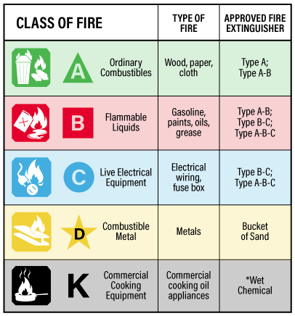

**Extinguisher type**

Fire extinguishers are rated for the class of fire they can be used on. Dry Chemical ABC extinguishers are found in most buildings and can be used on a broad range of fires.

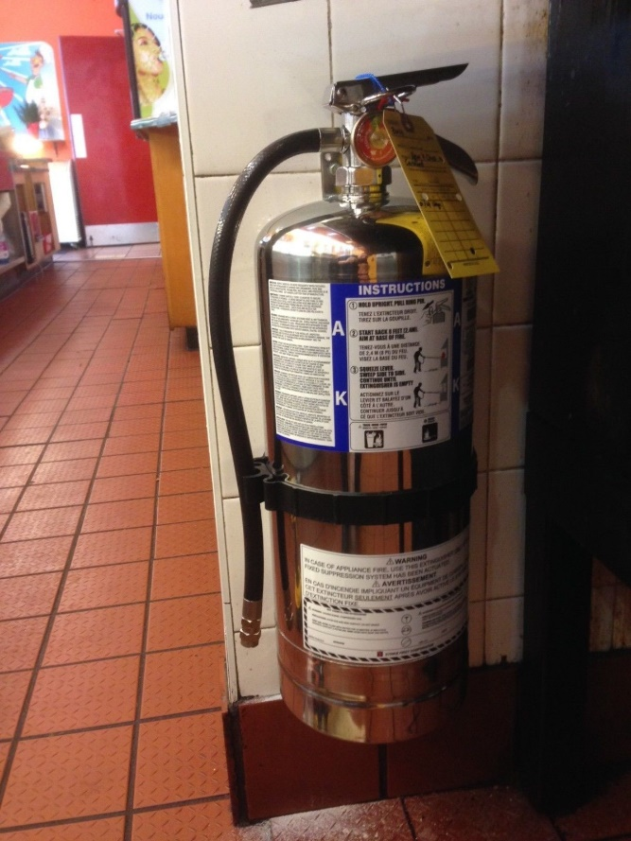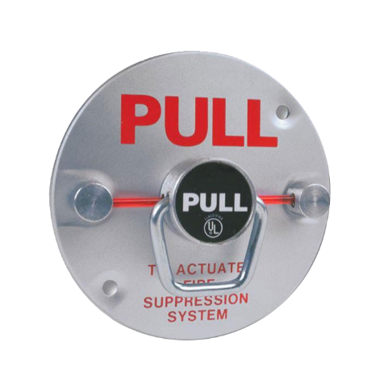

**Restaurant kitchen fires**

If a fire occurs under the commercial kitchen exhaust hood, first activate the hood fire suppression system by pulling the manual activation handle. The portable class ‘K’ extinguisher can then be used on any remaining fire.

Never put water on a grease fire!

**Responding to a fire alarm**

1. **General staff**

* Upon hearing a fire alarm staff should turn off equipment in their work area and prepare to evacuate.
* Encourage staff and members of the public to proceed calmly to the nearest exit.
* Provide assistance to those in need.
* Close doors in your work area and on your way to the exit.
* Once outside, proceed to the designated muster point and await direction.

1. **Supervisory or other designated staff**

* Proceed to fire alarm control panel to identify where alarm is coming from.
* Respond to the identified location to observe if there are any signs of fire.
* If fire is discovered, follow REACT instructions above.
* Call for additional assistance as required.
* If after completing a thorough investigation you determine that a false alarm has occurred, follow instructions for silencing the fire alarm panel.

**Silencing a fire alarm**

If after thorough investigation it is determined that there is no fire, **supervisory staff** may be given the authority to ‘silence’ the fire alarm bells.

Never ‘reset’ the fire alarm system until the fire department has investigated the source of the alarm and given the ok.

**System out of service**

If the fire alarm or sprinkler system is impaired and not able to be repaired immediately, alternative measures must be implemented to ensure building occupants remain protected. These measures should be discussed in cooperation with the fire department and may include the need for 24-hour fire watch to monitor the building for signs of fire. If a fire alarm system is out of service for more than 2 hours, the fire department must be notified by email at fireprevention@medicinehat.ca

**Part 5 - Fire Hazards**

Every employee has a responsibility for fire safety. By maintaining an awareness of hazards in your workplace and following proper housekeeping practices you can prevent fires.

Staff must report suspected fire hazards or other unsafe conditions to their supervisor immediately.

* Electrical equipment, wiring, and appliances must be kept in good working condition.
* Power cords must be fully inserted into outlets.
* Electrical power bars or power adapters where required must not be overloaded.
* Extension cords must be in good condition and should not be installed in place of permanent wiring.
* Ashtrays should be available at entrance doors where required. Ashtrays need to be maintained by removing butts and debris, and adding sand as required.
* Flammable and combustible liquids must be stored in approved containers and locations.
* Oily rags must be disposed of in approved containers.
* Combustible materials cannot be stored in a means of egress, stairwell, corridor, service space or service room.
* Maintain 1m clearance to electrical panels.
* Ensure space heaters have 1m clearance and will shut down if tipped over.
* Open flame must not be used for thawing pipes.

**Part 6 - Staff Training**

**Supervisory staff**

Supervisory staff shall be trained in the fire emergency procedures described in the fire safety plan before they are given any responsibility for fire safety.

Supervisory staff should be trained on how to silence and reset the fire alarm system.

Any keys or special devices needed to operate the fire alarm system, access locked areas, or provide access to any fire protection systems or equipment shall be readily available to on duty supervisory staff.

**General staff**

All staff should be familiar with the fire safety plan.

All staff should have received basic training on the use of portable fire extinguishers.

Staff must know the location of fire extinguishers in their work area.

Staff must know the location of exits from their work area.

**Part 7 - Fire Protection Maintenance Requirements**

The National Fire Code Alberta Edition outlines the tests, checks and inspections that must be performed on fire and life safety equipment. The reference information provided on the following pages outlines the basic requirements for most buildings but is not an exhaustive list of all requirements. For a full list of requirements refer to the National Fire Code Alberta Edition, National Building Code Alberta Edition, Safety Codes Act, or other referenced standards.

Records of tests, inspections, maintenance, or operational procedures shall be retained so that at least the current and the immediately preceding records are available.

|  |  |
| --- | --- |
| **Means of Egress** | Responsibility |
| Means of Egress shall be maintained in good repair and free of obstructions at all times. |  |
| Exit doors must be easily operable without any keys, tools, or special knowledge. Door release hardware, latches and locks shall be maintained in good working condition at all times. |  |
| Exterior passageways and exterior exit stairs shall be maintained free of ice and snow accumulations. |  |
| Exit doors must be tested **monthly** to ensure they are operable. |  |
|  |  |

|  |  |
| --- | --- |
| **Fire Separations** | Responsibility |
| Doors in fire separations shall not be obstructed, wedged, or blocked in any way to prevent them from closing properly. |  |
| Holes in fire separations must be repaired with appropriate fire rated materials. |  |
| Fire doors must be inspected **daily** to ensure they are kept closed. |  |
| Fire doors must be operated **monthly** to ensure they are properly maintained. |  |
| Fire and/or smoke dampers must be inspected every **year** to ensure they are in place and not damaged or obstructed. |  |
| Fire and/or smoke dampers must be tested every **4 years** to ensure proper operation. |  |
|  |  |

|  |  |
| --- | --- |
| **Exit and Emergency Lighting** CSA C282 | Responsibility |
| Exit pathways must be kept be illuminated at all times. |  |
| Exit signs checked **monthly** to ensure they are illuminated. |  |
| Emergency lighting operation must checked **monthly.** |  |
| Emergency generators must be checked **weekly**. |  |
| Emergency generators must be inspected **annually** by a qualified contractor. |  |
|  |  |

|  |  |
| --- | --- |
| **Commercial Kitchen** | Responsibility |
| Exhaust canopy filters to be inspected every **7 days** and cleaned when necessary. |  |
| Exhaust system to be inspected by qualified contractor at frequency indicated on previous inspection sticker. Maximum every **12 months.** |  |
| Suppression system to be inspected by qualified contractor every **6 months.** |  |
|  |  |

|  |  |
| --- | --- |
| **Fire Alarm System** CAN/ULC-S536 | Responsibility |
| Fire panel must be checked **daily** to ensure it is turned on and free of trouble indicators. |  |
| Fire alarm system requires **annual** inspection by qualified contractor. |  |
|  |  |

|  |  |
| --- | --- |
| **Fire Extinguishers** NFPA 10 | Responsibility |
| Fire extinguishers must be permanently mounted in a visible location along a path of travel to an exit. |  |
| Fire extinguishers must be checked **monthly** to ensure they are accessible, free of damage, and pressure gauge is within range. |  |
| Fire extinguishers must be inspected **annually** by a qualified contractor. |  |
|  |  |

|  |  |
| --- | --- |
| **Water Based Fire Suppression** NFPA 25 | Responsibility |
| Fire sprinkler valves and gauges must be checked **weekly.** |  |
| Fire Sprinkler systems must be inspected by a qualified contractor **annually.** |  |
| Fire hoses must be inspected by a qualified contractor **annually.** |  |
| Private fire hydrants must be inspected by a qualified contractor **annually**. |  |
| Fire pumps must be checked **weekly.** |  |
| Fire pumps must be inspected **annually** by a qualified contractor. |  |
|  |  |

|  |  |
| --- | --- |
| **Smoke & Carbon Monoxide Alarms** | Responsibility |
| Smoke & CO alarms must be installed in all dwelling units in accordance with the building code. Smoke & CO alarms must be replaced when they reach 10 years of age. |  |
| In hotels & motels, smoke alarms must be tested **monthly.** |  |
| In rental suites, smoke alarms must be tested when new tenants move in. Tenants are responsible for performing **monthly** tests. |  |
| In rental suites, owners are responsible for performing **annual** inspections. |  |
|  |  |

|  |  |
| --- | --- |
| **Fire Hazards** | Responsibility |
| Hoods, ducts, and filters should be inspected at least **weekly** to ensure there is no buildup of combustible deposits. |  |
| A **monthly** safety audit should be performed to identify any of the hazards listed in part 5 of this plan. |  |
|  |  |

**Part 8 – Building Diagrams**

Include a floorplan showing portable extinguisher and exit locations